SO4R Interlock
Logic Board
MCU code
Transfer Relay
Amplifier Multiplexer

Concept by Fred Lass K2TR
Implementation by Jeff Millar WA1HCO

Version 1

Interlock Overview

Interlock Schematic
Interlock PCB layout

SO4R_Interlock
The interlock manages up to 4 radios for the ARRL June and September VHF contest. The design follows the rules for those contests. Other contests have different rules.

Overall Design
- Four radios and 4 antennas on 6 meters
- One SSB/CW radio plus three WSJTX radios.
- Antenna separation is sufficient to allow reception when another radio is transmitting
- One amplifier shared among four radios
- SSB/CW radio has rotatable antenna
- Each WSJTX radio has an antenna (generally fixed, optionally rotatable)
- WSJTX feeds N1MM, Gridtracker or other program that display a combined list of stations needed.
- SSB/CW has highest priority and will stop transmission of WSJTX if necessary
- Operator can click on a station in the list and that WSJTX begins the contact.
- SSB/CW operator can continue to operate, which interrupts WSJTX transmission.

Overall Operation

Running Scenario
SSB/CW operator calling CQ on SSB/CW
Operator monitors a combined list of stations heard presented by N1MM, GridTracker, etc
Operator clicks on a station in the list and corresponding WSJTX enables TX
Operator continues CQ on SSB/CW while WSJTX is making contacts
PTT to WSJTX radio is interrupted when
while staying within the ARRL VHF contest rules

When a higher priority tranmitter needs to interrupt a lower priority tranmission,
the interlock gates the PTT line to the lower priority radio. This keeps the radio's
built in sequencer operating to protect the amplifier, preamp, and relays.
The interlock also controls the RF relays to disconnect the lower priority transmitter
and connect the highest priority transmitter

Radio Interface
* PTT, output open collector, low true, 60V, 300 mA
* KEY, input, open collector, low true, 5 to 15 V
* CAT, bidirectional, open collector, ttl levels, serial communication
* Spare, direct connection to MCU I/O pin

Relay interface
* 4 Relay control output with 60V 300 mA capability
* each output drives DPDT transfer relay and one port of 4:1 selector on both amp input and output

USB serial interface
* Implemented with FTDI FT230 usb serial chip
* TxD, RxD for CAT
* RTS, output, for signaling Transmit
* CTS, input, available, interfaced to MCU, no function assigned

SSB/CW radio interface
* highest priority radio, Priority = 1
* USB serial TxD, RxD used for MCU programming
* USB serial RTS used for keying radio from N1MM
* KEY signal from Radio used to set priority and control relays

WSJTX radio interface
* Lower priority radios, Priority = 2, 3, or 4
* USB serial implements COM port used by WSJTX software
* Serial data TxD and RxD converted to CAT bidirectional open collector
* RTS signal used for Tx command to radio
* CTS signal routed to MCU but not assigned a function

WSJTX operation
* Operator uses ssb/cw radio for contacts and has highest priority for transmitting.
* 3 WSJTX instances listen on 3 radios in 3 directions.
* Each WSJTX sends it list of callsigns to N1MM or Gridtracker which displays list of needed stations.
* The operator clicks on a callsign in the list to start a WSJTX contact.
* WSJTX indicates need to transmit by asserting RTS on its serial interface

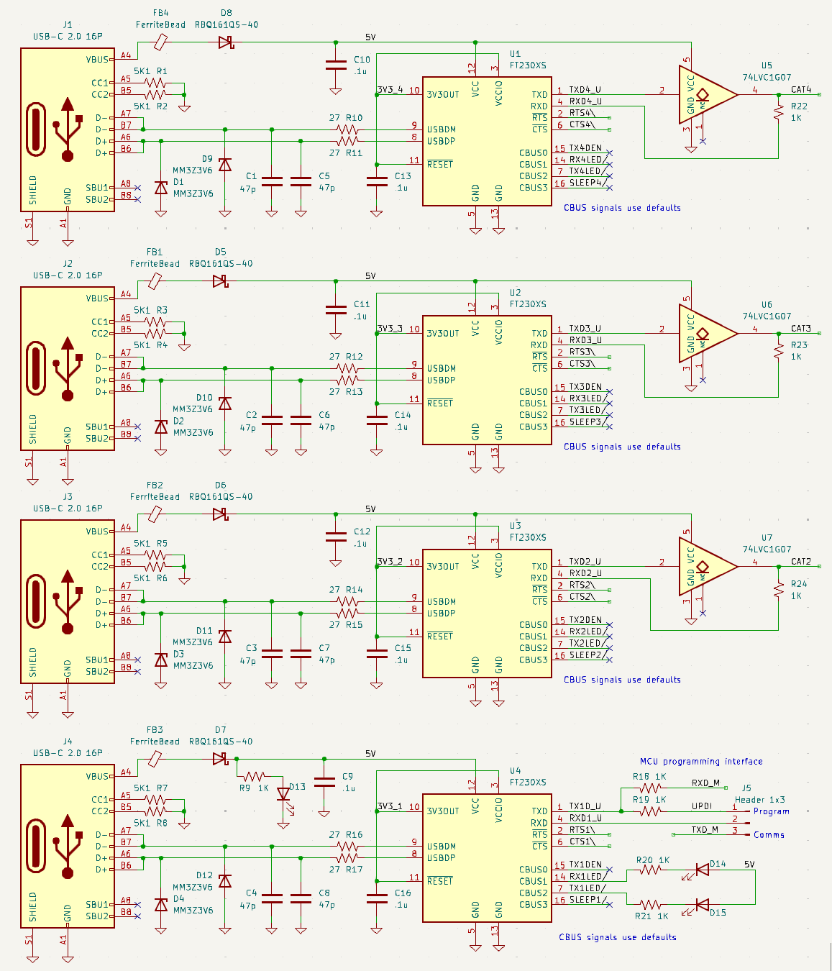
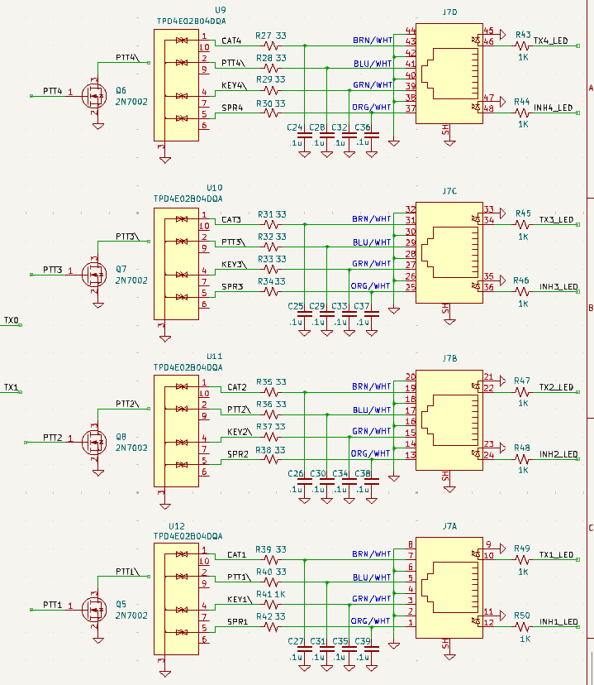

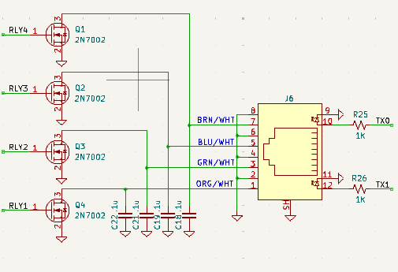
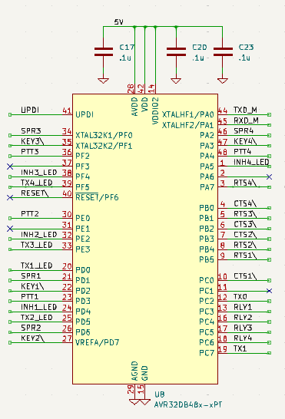
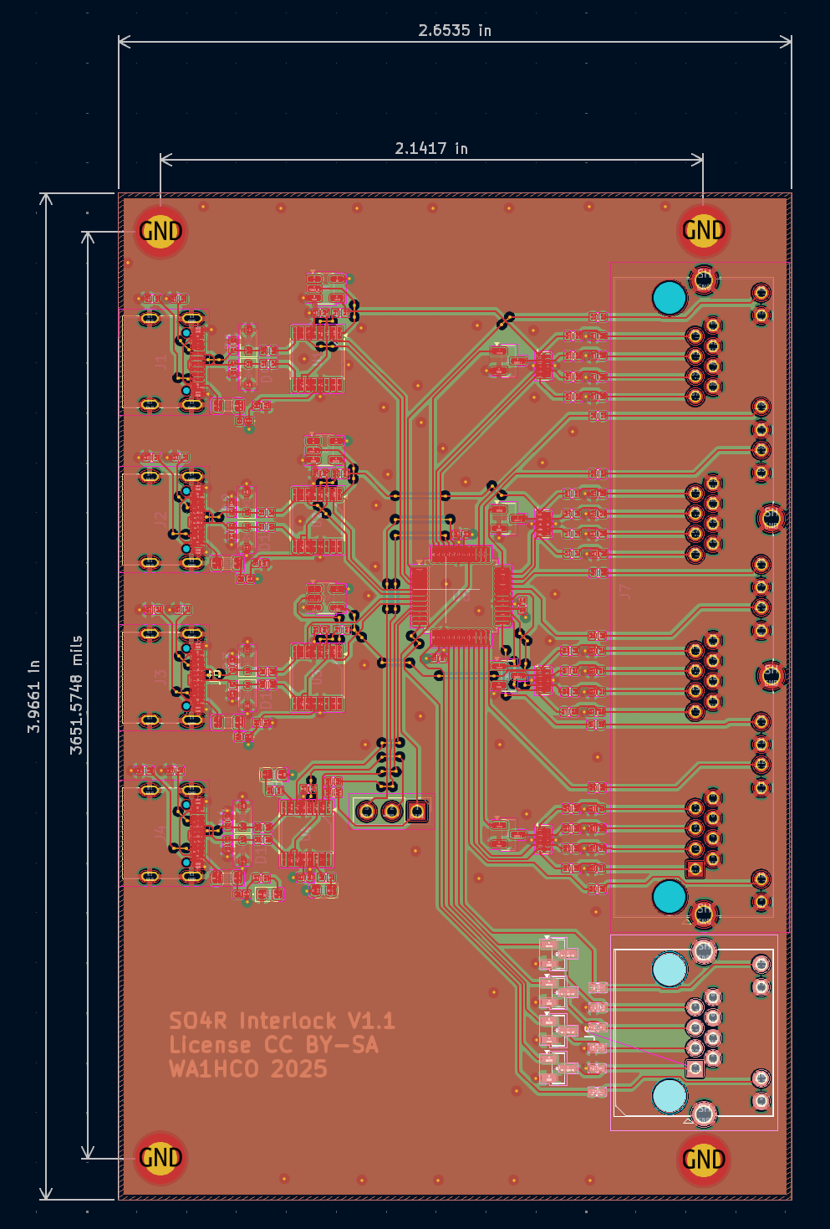

Radio Connectors

Icom IC-9700

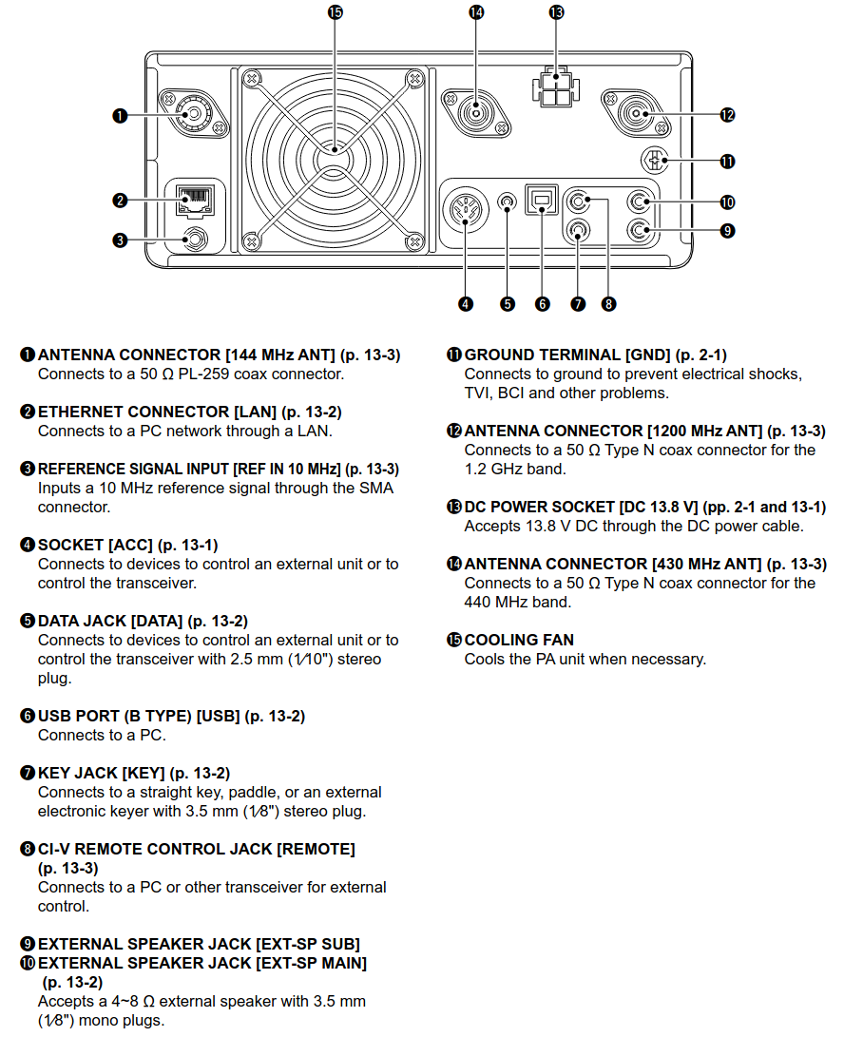

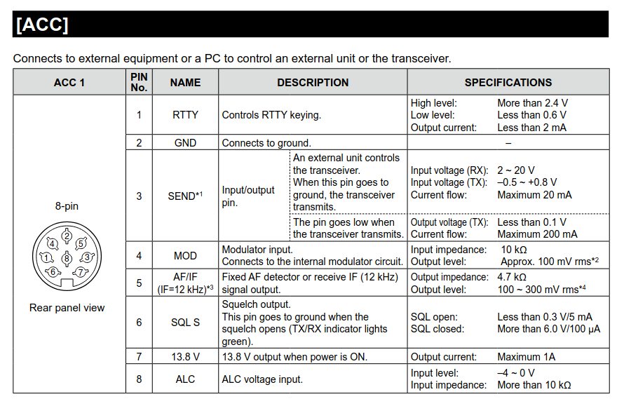
Note: Send is bidirectional can be used like PTT and asserted when radio goes to Tx from VOX, Tx button, etc. This mean that manually asserting Tx cannot be blocked. But if it is not highest priority, then the transfer relay remains in rig connected to antenna state and amplifier not deployed.

Icom IC-9100
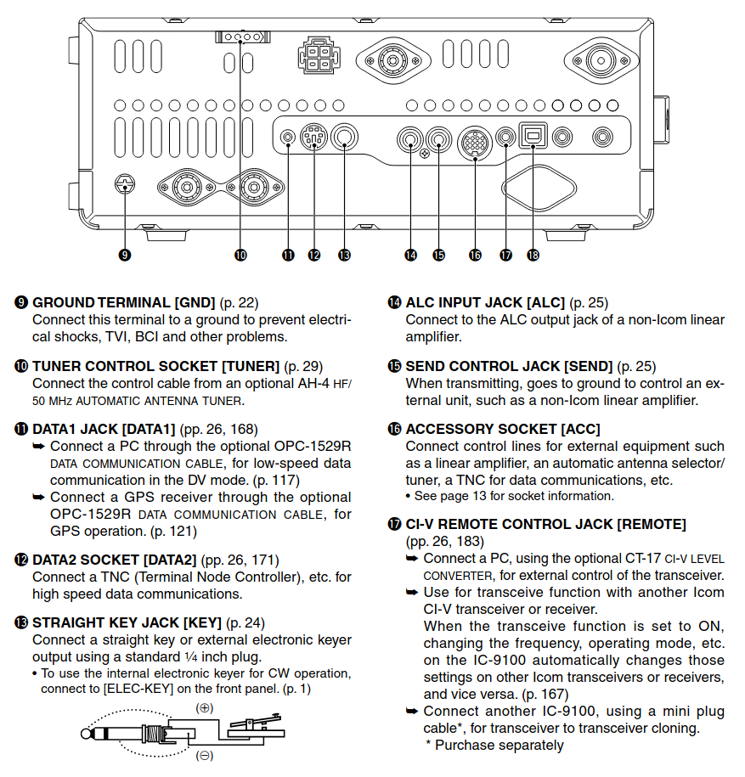

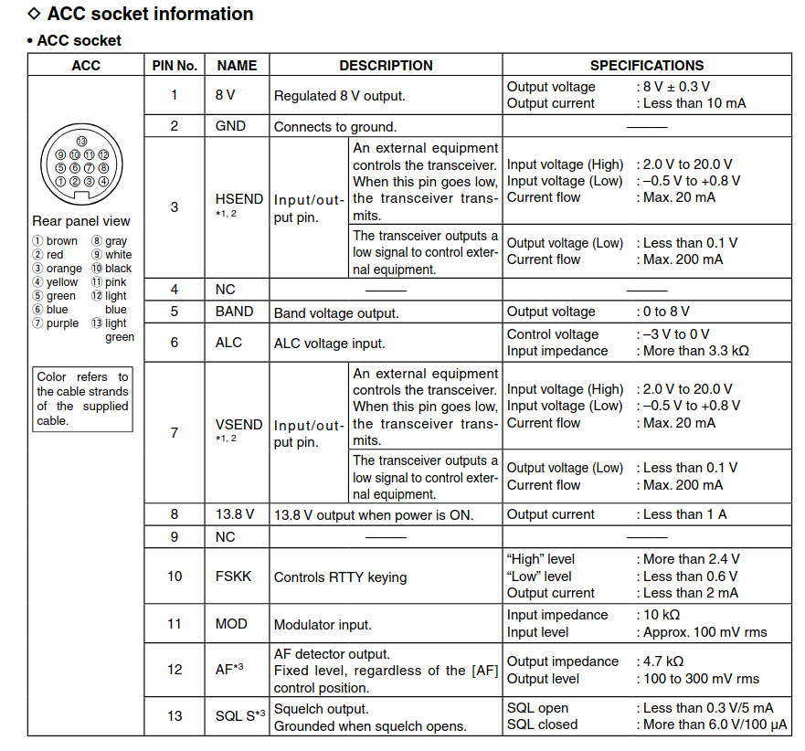

Icom IC-746Pro
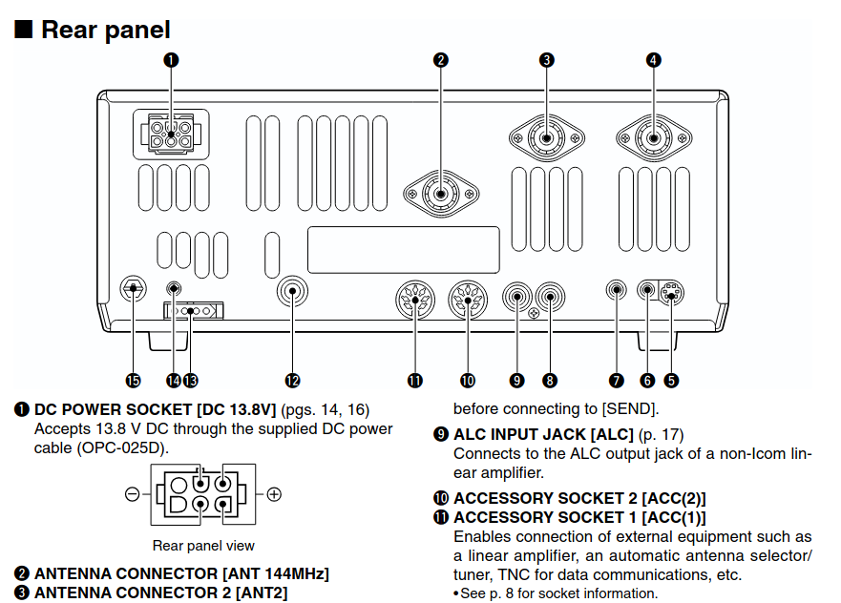
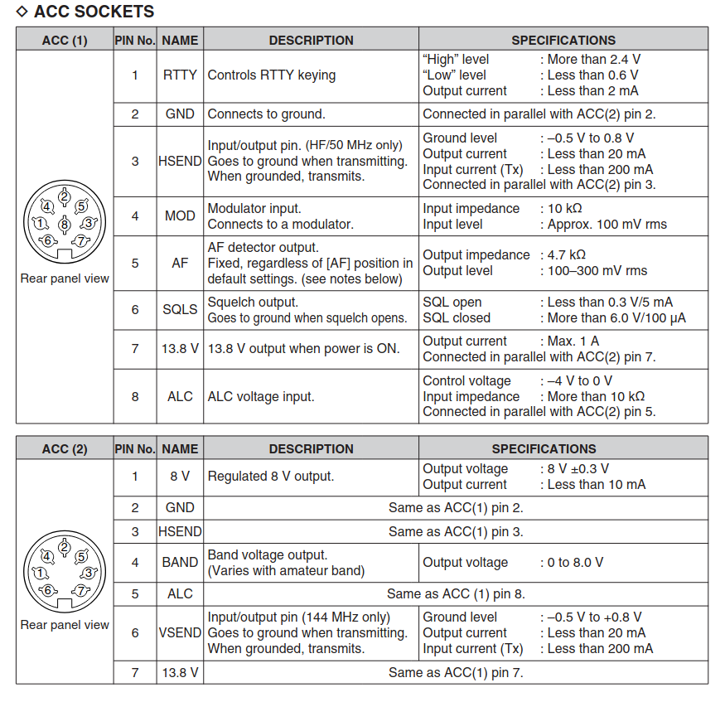

Elecraft K3
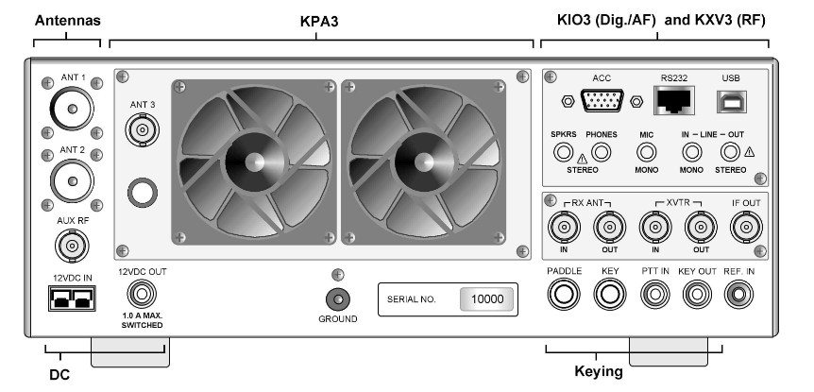
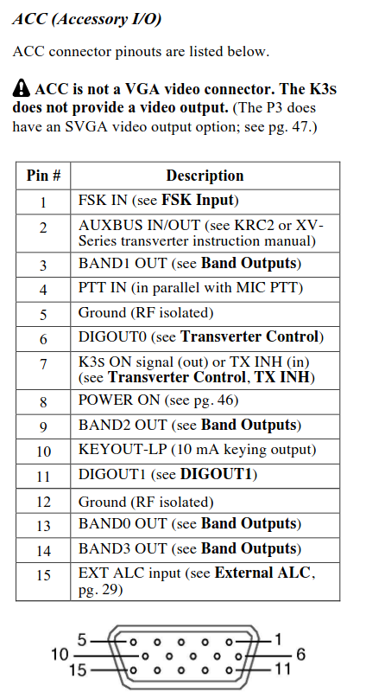

Elecraft K4
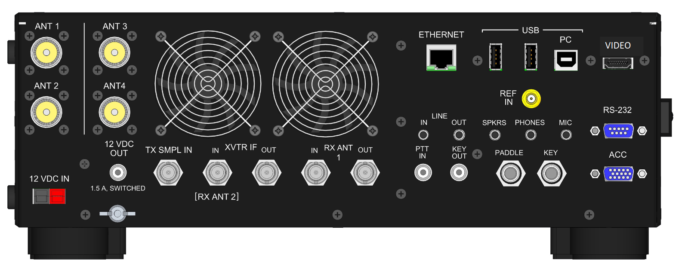
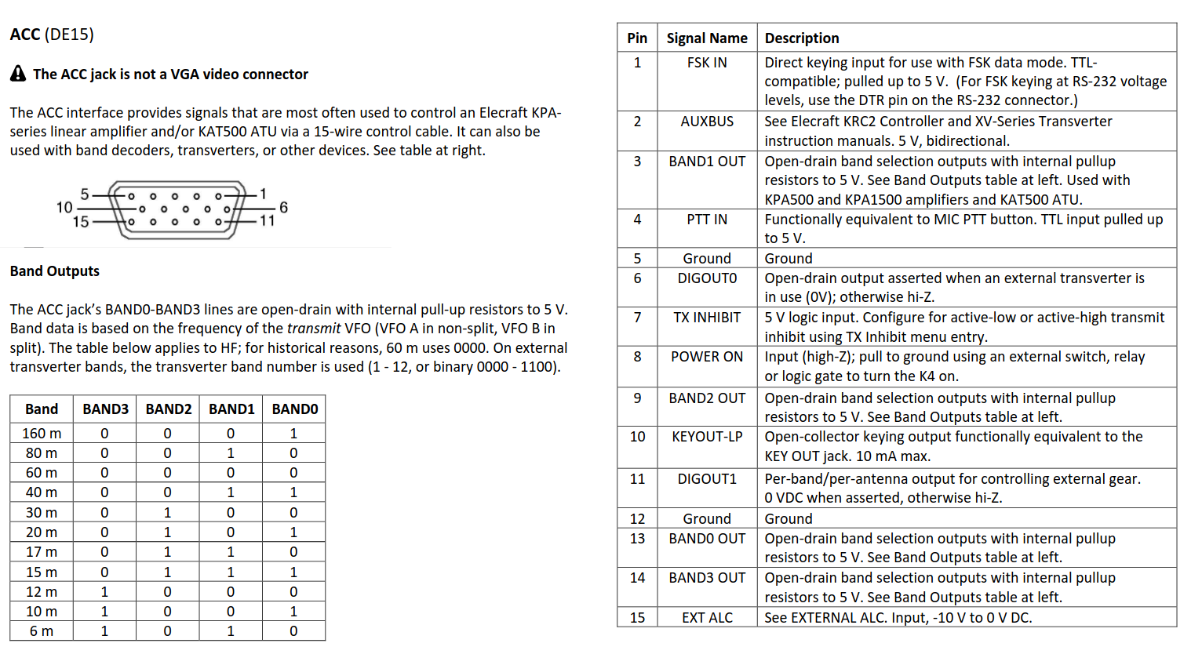

Yaesu FT-857
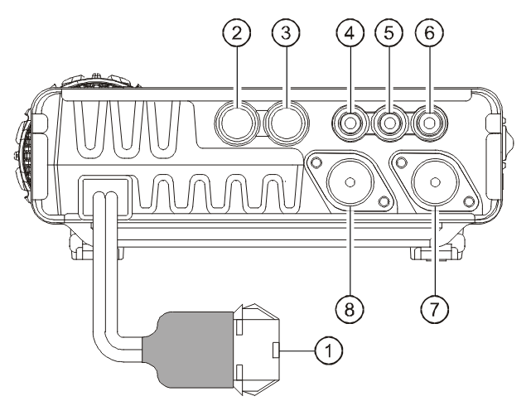

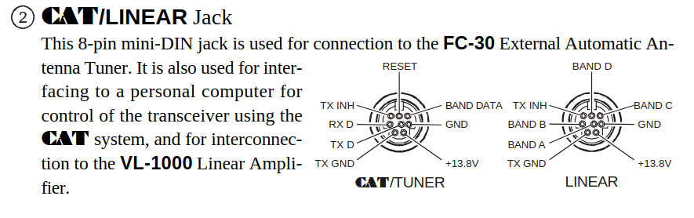
Note: Tx Gnd indicates radio in Tx mode, open collector , 50V 400 mA

